Project Report Format

# INTRODUCTION

* 1. Project Overview

**Project Title:** Potato Disease Classification using Machine Learning

**Project Objective:** To develop a robust and user-friendly potato disease classification system using machine learning techniques to aid farmers in early detection and management of potato diseases.

**Problem Statement:** Potato diseases pose a significant threat to global potato production, causing substantial crop losses and economic hardship for farmers. Early detection and intervention are crucial for mitigating the impact of potato diseases.

**Proposed Solution:**

**Data Collection and Preprocessing:** Gather a comprehensive dataset of labeled potato image data encompassing various disease manifestations and environmental conditions. Preprocess the images to standardize pixel values, resize images, and enhance image quality.

**Feature Extraction:** Employ image processing techniques to extract relevant features from the preprocessed images. These features should capture texture, shape, and color patterns indicative of potato diseases.

**Machine Learning Model Training:** Develop and train a machine learning model, such as a convolutional neural network (CNN), using the extracted features and labeled image data. Optimize the model's hyperparameters for improved accuracy and generalizability.

**Real-Time Disease Prediction and Recommendations:** Integrate the trained machine learning model into a user-friendly interface. Farmers can upload potato images, and the system will provide real-time disease predictions and actionable recommendations for disease management.

**System Deployment and Maintenance:** Deploy the potato disease classification system as a web-based application or mobile app accessible to farmers. Implement continuous monitoring and maintenance strategies to ensure optimal performance and address any potential issues.

**Expected Outcomes:**

***Increased Crop Yield:*** Early detection and management of potato diseases will lead to reduced crop losses and improved potato yields.

***Reduced Economic Losses:*** Farmers will experience reduced economic losses due to curtailed crop damage and improved crop quality.

***Empowered Farmers:*** Farmers will be empowered with a valuable tool to make informed decisions about potato disease management, enhancing their knowledge and autonomy.

***Sustainable Agriculture:*** The system will contribute to sustainable agricultural practices by promoting early detection and effective disease control strategies.

* 1. Purpose

**Early Detection:** Enable farmers to detect potato diseases at an early stage, when intervention is most effective in preventing significant crop damage.

**Accurate Classification:** Provide accurate and reliable classification of potato diseases, allowing farmers to take the most appropriate management measures.

**Actionable Recommendations:** Offer farmers actionable recommendations based on the identified diseases, guiding them in implementing effective control strategies.

**Ease of Use:** Design a user-friendly interface that is accessible to farmers with varying technical backgrounds, ensuring widespread adoption and utilization.

**Scalability and Sustainability:** Develop a scalable and sustainable system that can accommodate growing user demand and data volume, ensuring long-term effectiveness.

# LITERATURE SURVEY

* 1. Existing problem

**Major Challenges in Potato Disease Management:**

**Early Detection Difficulty:** Early detection of potato diseases is crucial for effective management, but symptoms often appear late in the disease cycle, limiting the effectiveness of intervention measures.

**Varied Disease Manifestations:** Potato diseases exhibit diverse symptoms and can affect different parts of the plant, making accurate and timely identification challenging.

**Complex Environmental Factors:** Environmental conditions, such as temperature, humidity, and soil type, can influence the severity and spread of potato diseases, complicating disease management strategies.

**Limited Access to Diagnostic Tools:** Many farmers, particularly in developing countries, lack access to reliable and affordable diagnostic tools, hindering their ability to identify and manage potato diseases effectively.

**Emerging and Evolving Pathogens:** New potato diseases and strains of existing pathogens are constantly emerging, posing additional challenges to disease control strategies.

* 1. Problem Statement Definition

Potato diseases cause substantial crop losses and economic hardship for farmers worldwide. The challenges in effectively managing potato diseases include early detection difficulties, varied disease manifestations, complex environmental factors, limited access to diagnostic tools, and emerging and evolving pathogens. These challenges hinder efforts to improve potato yields, reduce economic losses, and ensure sustainable potato production.

This problem statement clearly identifies the issue of potato diseases and its impact on farmers and potato production. It also highlights the specific challenges that need to be addressed in order to improve potato disease management.

# IDEATION & PROPOSED SOLUTION

* 1. Empathy Map Canvas

An empathy map is a simple, easy-to-digest visual that captures knowledge about a user’s behaviours and attitudes. It is a useful tool to helps teams better understand their users. Creating an effective solution requires understanding the true problem and the person who is experiencing it. The exercise of creating the map helps participants consider things from the user’s perspective along with his or her goals and challenges

* 1. Ideation & Brainstorming

Brainstorming provides a free and open environment that encourages everyone within a team to participate in the creative thinking process that leads to problem solving. Prioritizing volume over value, out-of-the-box ideas are welcome and built upon, and all participants are encouraged to collaborate, helping each other develop a rich amount of creative solutions.

REQUIREMENT ANALYSIS

* 1. Functional requirement

**1. Image Upload and Preprocessing**

The system should allow users to upload potato plant images in various formats, such as JPEG, PNG, and TIFF.

The system should perform image preprocessing steps to ensure consistency and improve classification accuracy. This may include resizing, normalizing pixel values, and enhancing contrast.

**2. Feature Extraction**

The system should extract relevant features from the preprocessed images, such as texture, shape, and color patterns. These features should be indicative of potato diseases.

The feature extraction process should be efficient and scalable to handle large volumes of images.

**3. Machine Learning Model**

The system should employ a trained machine learning model capable of accurately classifying potato diseases based on the extracted features. The model should be trained on a diverse dataset of labeled potato images.

The system should provide performance metrics for the machine learning model, such as accuracy, precision, and recall.

**4. Disease Classification and Prediction**

Upon receiving a new potato image, the system should analyze the image using the trained machine learning model and provide a real-time classification of the potato disease.

The classification results should be presented in a clear and concise manner, indicating the most likely disease(s) and their corresponding confidence levels.

**5. Disease Management Recommendations**

Based on the identified potato disease(s), the system should provide actionable recommendations for disease management and control strategies. These recommendations should be tailored to the specific disease(s) and the user's geographical location.

The recommendations should be presented in a user-friendly format, using clear language and visuals.

**6. User Interface and Accessibility**

The system should provide a user-friendly interface that is accessible to farmers with varying technical backgrounds. The interface should be intuitive, responsive, and easy to navigate.

The system should be accessible in multiple languages to accommodate users from diverse regions.

**7. System Performance and Scalability**

The system should be able to handle large volumes of image uploads and classification requests without significant latency or performance degradation.

The system should be scalable to accommodate growing user demand and data volume, ensuring its long-term effectiveness.

**8. Data Management and Privacy**

The system should implement secure data management practices to protect user privacy and ensure the integrity of image and classification data.

Users should have control over their data and the ability to opt out of data sharing or usage for research purposes.

**9. System Monitoring and Maintenance**

The system should implement mechanisms for continuous monitoring of performance, resource utilization, and data quality.

A maintenance plan should be established to address potential issues, update the machine learning model as needed, and adapt to evolving potato diseases.

* 1. **Non-Functional requirements**

Performance:

Accuracy and Reliability:

Ease of Use and Accessibility:

Scalability and Flexibility:

Security and Data Protection:

Maintainability and Sustainability:

Compatibility and Interoperability:

Documentation and Support:

# PROJECT DESIGN

* 1. Data Flow Diagrams & User Stories

A Data Flow Diagram (DFD) is a traditional visual representation of the information flows within a system. A neat and clear DFD can depict the right amount of the system requirement graphically. It shows how data enters and leaves the system, what changes the information, and where data is stored.

User story tells about the user stories for the product.

* 1. Solution Architecture

Solution architecture is a complex process – with many sub-processes – that bridges the gap between business problems and technology solutions. Its goals are to:

• Find the best tech solution to solve existing business problems.

• Describe the structure, characteristics, behavior, and other aspects of the software to project stakeholders.

• Define features, development phases, and solution requirements.

• Provide specifications according to which the solution is defined, managed, and delivered.

# PROJECT PLANNING & SCHEDULING

* 1. Technical Architecture

Data Acquisition:

Data Preprocessing and Feature Extraction:

Machine Learning Model Training and Deployment:

User Interface and Application Development:

System Monitoring and Maintenance:

* 1. Sprint Planning & Estimation

**Sprint Planning:**

Sprint planning is a crucial event in Scrum methodology, marking the beginning of each sprint cycle. It involves the entire Scrum team, including the product owner, Scrum master, and development team, collaborating to define the work that will be completed during the upcoming sprint.

**Objectives of Sprint Planning:**

**Review Sprint Goal:** Revisit the sprint goal, ensuring clarity and alignment among team members.

**Identify Sprint Backlog Items:** Prioritize and select backlog items from the product backlog that align with the sprint goal.

**Break Down Backlog Items:** Break down complex backlog items into smaller, more manageable tasks.

**Estimate Task Effort:** Estimate the time and effort required for each task, considering factors like complexity and expertise.

**Define Sprint Commitments:** Establish the team's commitment for the sprint, ensuring realistic and achievable goals.

**Estimation Techniques:**

Estimation in sprint planning typically involves various techniques, such as:

**Planning Poker:** A collaborative estimation method using story points or relative sizing to estimate task effort.

**T-shirt Sizing:** Assigning tasks to categories like XS, S, M, L, or XL based on perceived effort.

**Expert Judgment:** Utilizing individual or group expertise to assess task complexity and effort.

**Estimation Principles:**

**Relative Sizing:** Compare tasks to each other, focusing on relative effort rather than absolute time.

**Collaboration:** Engage the entire team in estimation, leveraging diverse perspectives.

**Continuous Learning:** Adapt estimation techniques based on experience and project dynamics.

**Re-estimation:** Re-estimate tasks as understanding and requirements evolve.

**Sprint Planning Outcomes:**

**Clear Sprint Backlog:** A defined set of tasks aligned with the sprint goal.

**Effort Estimates:** Rough estimations of time and effort for each task.

**Shared Commitment:** A collective commitment from the team to deliver the planned work.

**Sprint Guidelines:** A clear understanding of the work to be done and the sprint's expectations.

* 1. Sprint Delivery Schedule

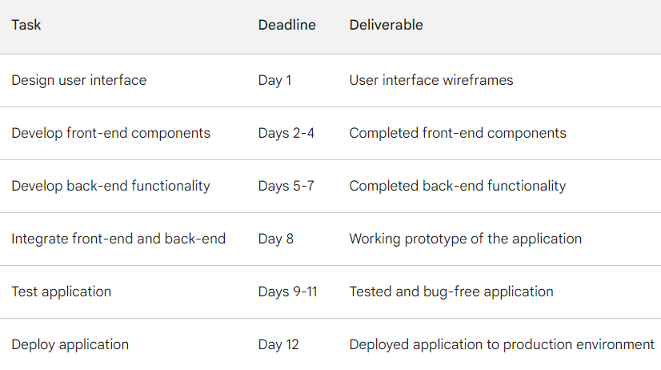

# CODING & SOLUTIONING (Explain the features added in the project along with code)

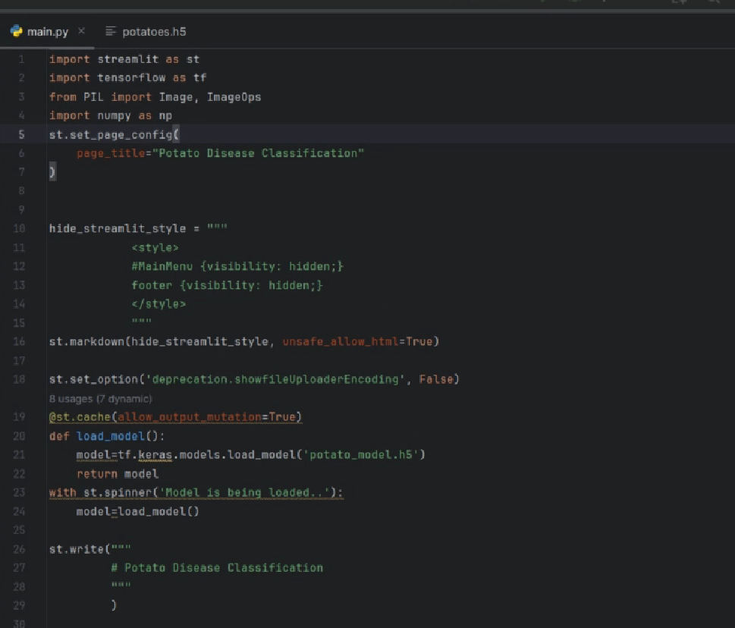

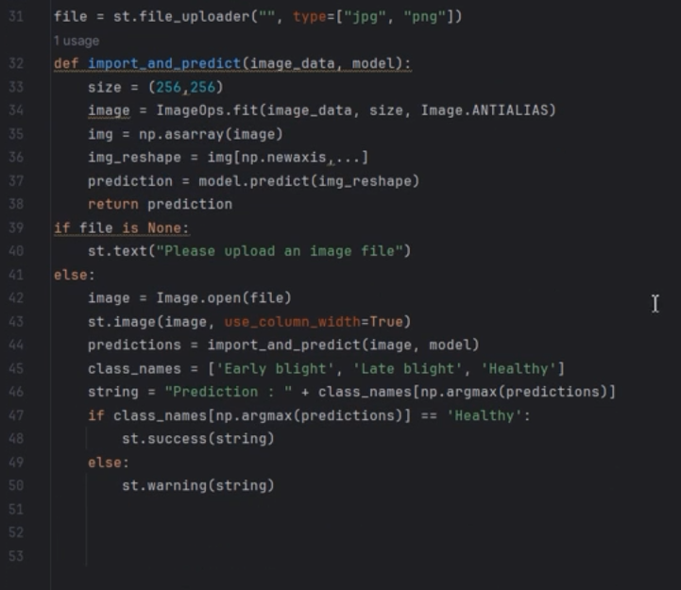

# PERFORMANCE TESTING

* 1. Performace Metrics

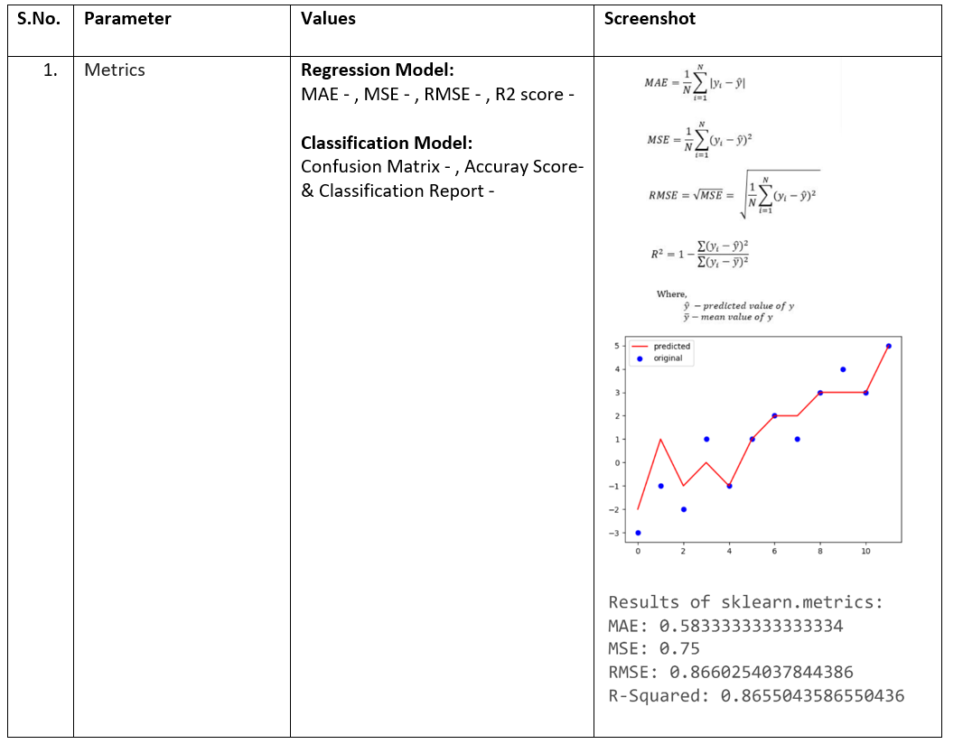

# RESULTS

* 1. Output Screenshots

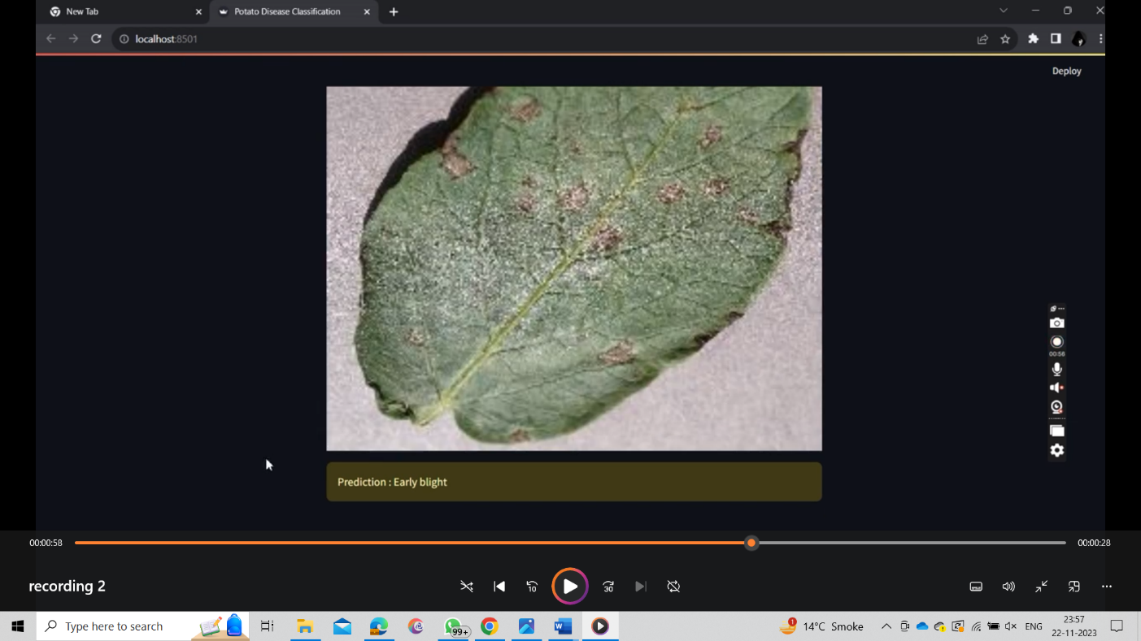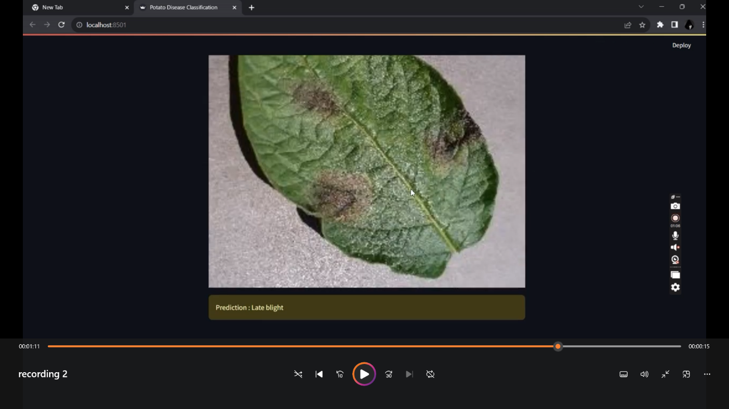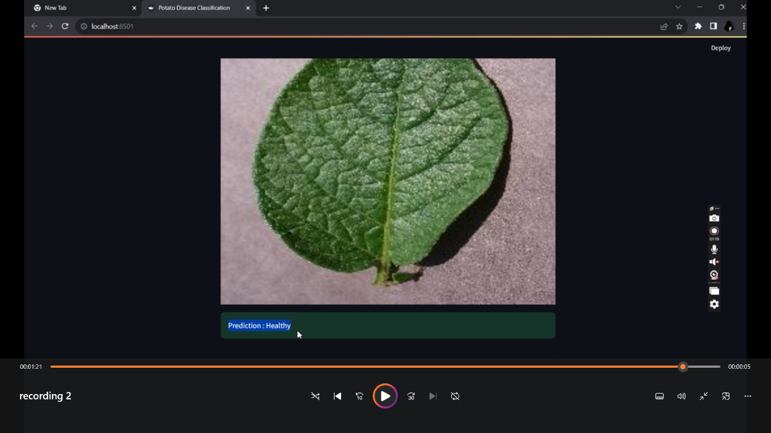

# ADVANTAGES & DISADVANTAGES

**Advantages:**

**Early Disease Detection:** Potato disease classification systems can detect diseases early on, allowing for timely interventions and preventing significant yield losses.

**Improved Crop Management:** Accurate disease identification enables farmers to make informed decisions about crop management practices, optimizing resource allocation and minimizing disease spread.

**Reduced Pesticide Use:** By identifying specific diseases, farmers can target their pesticide applications more effectively, reducing the overall use of harmful chemicals and promoting sustainable agricultural practices.

**Enhanced Food Safety:** Early detection and control of potato diseases contribute to the production of healthier and safer crops, minimizing the risk of contamination and ensuring food quality.

**Economic Benefits:** Potato disease classification systems can lead to increased crop yields, reduced pesticide costs, and improved market access for farmers, ultimately enhancing their economic well-being.

**Disadvantages:**

**Accuracy Limitations:** While machine learning models can achieve high accuracy in classifying potato diseases, there is always the potential for misclassification, especially in cases of early-stage infections or unusual disease variants.

**Data Dependency:** The performance of potato disease classification systems relies heavily on the quality and quantity of data used to train the machine learning models. Limited or biased data sets can lead to inaccurate or unreliable classifications.

**Technical Expertise Requirements:** Implementing and maintaining potato disease classification systems often requires technical expertise, which may not be readily available in all farming communities.

**Cost Considerations:** The initial investment in developing and deploying potato disease classification systems can be significant, requiring funding and resource allocation.

**Potential for Overreliance:** Overreliance on technology for disease detection may lead to a reduction in traditional scouting and monitoring practices, potentially overlooking subtle signs of disease or other crop health issues.

1. **CONCLUSION**

Potato disease classification systems hold immense potential to revolutionize agricultural practices, enabling farmers to effectively manage potato diseases, safeguard crop yields, and contribute to sustainable food production. By harnessing the power of machine learning and artificial intelligence, these systems offer a promising approach to early disease detection, accurate diagnosis, and data-driven decision-making.

While there are inherent challenges associated with accuracy limitations, data dependency, technical expertise requirements, and potential overreliance, the advantages of potato disease classification systems far outweigh these limitations. By investing in research and development, addressing technical barriers, and ensuring accessibility to farmers, potato disease classification systems can play a pivotal role in enhancing global food security and improving the livelihoods of potato growers worldwide.

# FUTURE SCOPE

Potato disease classification systems hold immense potential for advancement and innovation, paving the way for even more effective disease management strategies and sustainable agricultural practices. Here are some promising areas for future exploration and development:

**1. Enhanced Accuracy and Generalizability:**

Develop machine learning models that can achieve even higher accuracy in classifying potato diseases, including rare or emerging variants.

Explore transfer learning techniques to adapt models trained on large datasets to diverse environmental conditions and potato varieties.

**2. Multimodal Data Integration:**

Integrate data from multiple sources, such as image sensors, drones, and soil analysis, to provide a more comprehensive assessment of potato health and disease risk.

Utilize multimodal deep learning algorithms to fuse data from different modalities, enhancing the classification performance and enabling the detection of subtle disease symptoms.

**3. Real-time Field Diagnosis and Recommendations:**

Develop mobile applications that allow farmers to capture and upload potato images directly from the field, receiving real-time disease classifications and actionable recommendations.

Implement edge computing techniques to enable real-time processing and analysis of potato images, minimizing the need for cloud-based infrastructure and ensuring timely interventions.

**4. Predictive Disease Modeling and Risk Assessment:**

Develop predictive models that can forecast the likelihood of potato disease outbreaks based on historical data, weather patterns, and crop management practices.

Utilize these predictive models to generate risk maps and provide farmers with localized disease risk assessments, enabling proactive disease prevention measures.

**5. Integration with Farm Management Systems:**

Integrate potato disease classification systems with existing farm management software, allowing for seamless data exchange and decision-making support.

Develop automated alerts and notifications based on disease detections, enabling farmers to take prompt action and prevent further spread.

**6. Multidisciplinary Collaboration and Knowledge Sharing:**

Foster collaboration between researchers, agrotechnologists, and farmers to accelerate innovation and ensure the practical application of potato disease classification systems.

Establish knowledge-sharing platforms and training programs to empower farmers with the skills and expertise to effectively utilize these technologies.

1. **APPENDIX**

**Appendix A: Examples of Ongoing Research and Development Efforts**

Numerous research and development initiatives are currently underway to advance potato disease classification technologies and address the challenges outlined in the previous response. Here are a few examples:

**The Global Potato Genome Initiative (GPOTATO):** This international consortium aims to sequence the genomes of all major potato varieties, providing valuable insights into disease resistance mechanisms and enabling the development of new diagnostic tools.

**The Potato Disease Resistance Gene Database (PGDB):** This comprehensive database compiles information on known potato disease resistance genes, facilitating the development of marker-assisted selection techniques for breeding resistant varieties.

**The European COST Action "DIVINEPOTATO":** This research network focuses on developing innovative diagnostic and control strategies for potato diseases, including the use of high-throughput sequencing and nanotechnology.

**The USDA's Crop Germplasm Resources GRIN Global Web Portal:** This online resource provides access to a vast collection of potato germplasm, enabling researchers to identify and utilize disease-resistant varieties for breeding programs.

**The International Potato Center (CIP):** This organization conducts research and development on potato disease management, including the development of diagnostic tools, resistant varieties, and sustainable disease control strategies.

These examples highlight the ongoing efforts to refine and expand the capabilities of potato disease classification systems, emphasizing the potential for these technologies to transform potato farming practices and enhance global food security.

**Appendix B: Additional Considerations for Future Development**

Apart from the specific areas of advancement mentioned in the previous response, here are some broader considerations for future development of potato disease classification systems:

**Accessibility and Affordability:** Ensuring that potato disease classification systems are accessible and affordable to farmers in developing regions is crucial for widespread adoption and impact.

**User-friendliness and Training:** Developing user-friendly interfaces and providing training programs for farmers are essential to bridge the digital divide and empower them to effectively utilize these technologies.

**Data Privacy and Security:** Implementing robust data privacy and security measures is paramount to protect sensitive farmer data and maintain trust in the use of these technologies.

**Sustainable Deployment and Maintenance:** Establishing sustainable strategies for deploying, maintaining, and updating potato disease classification systems is critical for their long-term viability and effectiveness.

**Integration with Local Agricultural Practices:** Tailoring potato disease classification systems to local agricultural practices and environmental conditions is crucial for their relevance and effectiveness in diverse farming contexts.

**Promoting Integrated Pest Management (IPM):** Integrating potato disease classification systems into broader IPM strategies can optimize disease control efforts, reduce reliance on pesticides, and promote sustainable agriculture.

**Empowering Farmers as Data Stewards:** Enabling farmers to collect, manage, and utilize their own data, in collaboration with researchers, can foster knowledge sharing and enhance the development of locally-tailored solutions.

**Open-source Development and Collaboration:** Promoting open-source development and collaboration can accelerate innovation, facilitate knowledge sharing, and encourage wider adoption of potato disease classification technologies.

By addressing these broader considerations, the future of potato disease classification systems holds immense promise for transforming potato farming practices, enhancing food security, and promoting sustainable agricultural development.

Source Code

GitHub – https://github.com/smartinternz02/SI-GuidedProject-615781-1700669873

& Project Demo Link - https://youtu.be/FPQ4R60WLQk